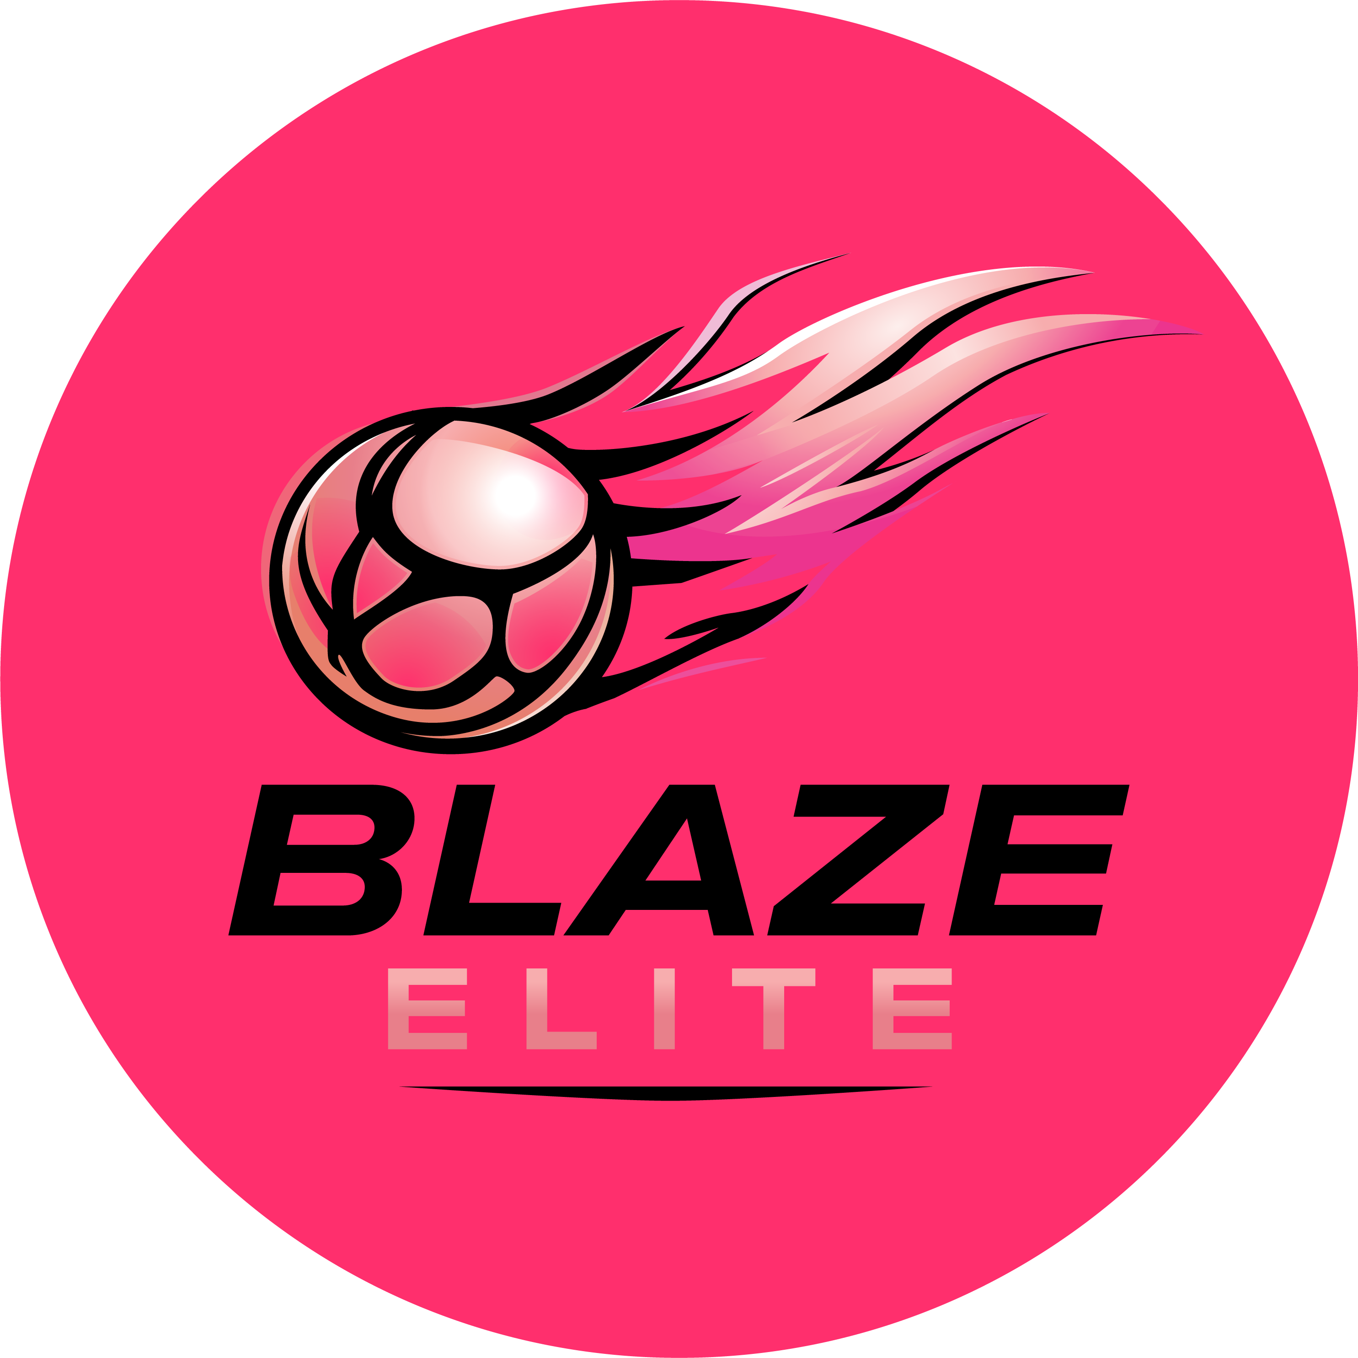

Supporters Code of Conduct
Blaze Elite Netball Club
This Code applies to anyone supporting Blaze Elite athletes at training, matches or tournaments who is not a parent/guardian bound by the Parent/Guardian Code of Conduct — for example, siblings, grandparents, or other family and friends.

1. At Matches & Training
- Encourage adherence to the rules of netball, and play within them.
- Support athletes' involvement and help their enjoyment of the sport.
- Publicly, and with grace, accept an official's judgment, including that of coaches.
- Discourage unfair play and dissent with officials.
- Set a good example, recognise fair play, and congratulate all athletes' performances, not just those you know.
- Help athletes recognise good performance, not just results.
- Never punish or belittle any participant for losing or making a mistake.
- Use correct and appropriate language at all times.

2. Viewing & Photography
- Respect viewing regulations at matches; courtside viewing is not permitted at training.
- Do not take photographs or video without the club's permission — see the Photography & Video Policy.

